|  |  |
| --- | --- |
| EX NO: 05 | **AREA CALCULATOR** |
| DATE : 22-08-19 |

**Aim:**

To develop a java console application to perform area calculation using abstract classes. **Requirement:**

Create an abstract class named Shape that contains two integers and an empty method named print Area().

Three classes named Rectangle, Triangle and Circle such that each one of the classes extends the class Shape.

Each one of the classes contains only the method print Area () that prints the area of the given shape.

**Algorithm:**

**Step 1**: Create class StringList with static main function in package stringcollection.

**Step 2**: Use switch case to perform necessary tasks.

**Step 3**: Use add() method to add a string.

**Step 4**: Use same add() method to add a string at particular index.

**Step 5**: Use indexOf() method to search for a string.

**Step 6**: Compare first letter of the strings from the list with the entered letter and display those particular strings.

**Step 7**: Exit

**CLASS DIAGRAM**

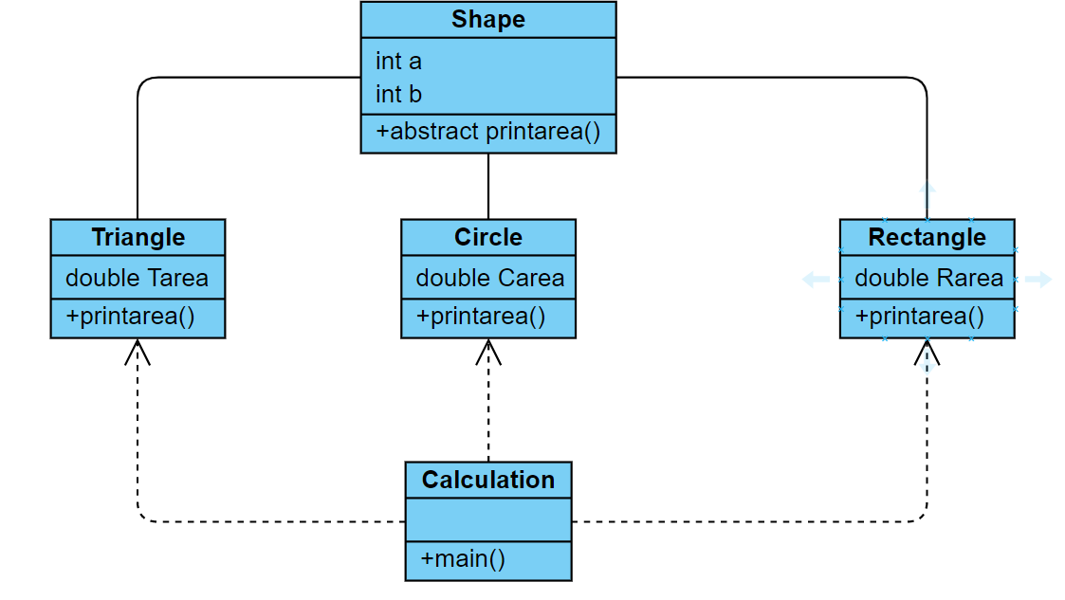

**PROGRAM:**

/*******

* created by Akhshy Ganesh

* Gmail: akhshyganeshb@gmail.com

* program to calculate area

*/

package AreaCalculator;

import java.util.Scanner;

public class Calculation {

public static void main(String[]args) {

int option;

Scanner sc=new Scanner(System.in);

Circle c;

c=new Circle();

Rectangle r;

r=new Rectangle();

Triangle t;

t=new Triangle();

while(true)

{

System.out.println("1.To find the area of Circle:");

System.out.println("2.To find the area of Rectangle:");

System.out.println("3.To find the area of Triangle:");

System.out.println("4.Exit");

System.out.println("ENTER YOUR OPTIONS!!!!!!!");

option=sc.nextInt();

switch(option)

{

case 1:

c.printarea();

System.out.println("-----------------------------------");

break;

case 2:

r.printarea();

System.out.println("-----------------------------------");

break;

case 3:

t.printarea();

System.out.println("-----------------------------------");

break;

case 4:

System.out.println("Thank you for using area calculator");

System.out.println("-----------------------------------");

break;

default:

System.out.println("Please enter a valid number:");

System.out.println("-----------------------------------");

break;

}

}

}

}

package AreaCalculator;

import java.util.Scanner;

public class Circle extends Shape {

Double Carea;

Scanner sc=new Scanner(System.*in*);

void printarea() {

System.*out*.println("Enter the radius of the circle:");

a=sc.nextInt();

Carea=(double)(3.14*a*a);

System.*out*.println("The area of the circle is:"+Carea);

}

}

package AreaCalculator;

import java.util.Scanner;

public class Rectangle extends Shape{

Double Rarea;

Scanner sc =new Scanner(System.*in*);

void printarea() {

System.*out*.println("Enter the height and breadth of Rectangle: ");

a=sc.nextInt();

b=sc.nextInt();

Rarea=(double) (a*b);

System.*out*.println("The area of Reactangle is: "+Rarea);

}

}

package AreaCalculator;

public abstract class Shape {

int a,b;

abstract void printarea();

}

package AreaCalculator;

import java.util.Scanner;

public class Triangle extends Shape{

double Tarea;

Scanner sc= new Scanner(System.*in*);

void printarea() {

System.*out*.println("Enter the base and height of the triangle: ");

a=sc.nextInt();

b=sc.nextInt();

Tarea=(0.5*a*b);

System.*out*.println("The area of triangle is:"+Tarea);

}

}

**OUTPUT:**

1.To find the area of Circle:

2.To find the area of Rectangle:

3.To find the area of Triangle:

4.Exit

ENTER YOUR OPTIONS!!!!!!!

1

Enter the radius of the circle:

2

The area of the circle is:12.56

-----------------------------------

1.To find the area of Circle:

2.To find the area of Rectangle:

3.To find the area of Triangle:

4.Exit

ENTER YOUR OPTIONS!!!!!!!

2

Enter the height and breadth of Rectangle:

5

6

The area of Reactangle is: 30.0

-----------------------------------

1.To find the area of Circle:

2.To find the area of Rectangle:

3.To find the area of Triangle:

4.Exit

ENTER YOUR OPTIONS!!!!!!!

3

Enter the base and height of the triangle:

5

4

The area of triangle is:10.0

-----------------------------------

1.To find the area of Circle:

2.To find the area of Rectangle:

3.To find the area of Triangle:

4.Exit

ENTER YOUR OPTIONS!!!!!!!

4

Thank you for using area calculator

**RESULT:**

Thus the java application for area calculation is executed and the output is verified succesfully.